Issues for Module 3 as of 9/27/2015

#18: the problem is still not fixed.
“When posting a task, and uploading files, I chose a .jpg. The file does not stay.
I get an error msg:
"An Error Was Encountered
The URI you submitted has disallowed characters."
PIPL[23-09-2015] : We have done please have a look.

Lilian [9-26]: it tested OK. Thanks. But can we just show the picture as a small icon on the screen, instead of users have to click on “Download to see”? You have this feature properly implemented in “Creating Service Profile”. Can you do the same thing here, to be consistent?

However I discover a new related issue. Please see issue #?
---------------------------------------------
# 25: photo cropping only goes up and down. But it also needs to allow users to crop left and right.
Amol’s Answer: for first point, if we add random size croping , (by mean we say left right croping too), the image uploaded will get stretched and will make the image blurr, as this croping is only for cover image in the service provider profile , it is essential to have un stretched fixed size image
Lilian’s comment [9-20]: crop box does not come out. The program still forces me to crop.
Also, the cropping box dimension needs to be calculated. The image should be resized, besides cropping action. The final image will appear on the public profile.
PIPL[23-09-2015] : We have done please have a look.

Lilian [9-26]: The cropping function is working now. But I’m not sure what happened to the cropped photo. How does site use this cropped photo? When it comes back to the editing screen, the photo shown is still the original photo. The public view of profile is not using the cropped photo. It still is not re-sizing photo.

It’s not showing right away. But after I click “save” button, the editing screen is showing the cropped one.

See example: “Test3”, or “CastingAgent1”
--------------------------------------
26. Change a Cover Photo for service profile takes a long time now, after the cropping function is introduced. It's causing the site to hang, and time out.
Amol’s answer: we used the same server website id , and tested for the second issue , it is working very fine.
- Lilian’s comment: put some sort of progress indicator on top to show progress: for a large picture, this might take up to 1 minute. Now the screen does nothing, I end up leaving the page, thinking the feature didn’t work.
PIPL[23-09-2015] : Effect will be seen when site is live.

Lilian [9-26]: Will keep this issue as open until the site is live.
-----------------------------------------------------

27. This is a new bug that got introduced: when you create a new service profiel, i select a cover photo, the site always considers "No File selected. Please choose cover image". So i can't save this service profile at all.
Amol’s answer: yes it is a bug , and we will resolve it , will tell you when it is done
PIPL[23-09-2015] : It has been resolved but check once.
-----------------------------------

28. How do we change the picture for Profile? There is not a field for that.
Amol’s answer: a user need to click , on the grey dot to change his profile image
Lilian’s comment: This works well. It’s cropping the picture only recognizing the human in the pictures automatically. However, it could uses improvements.
PIPL[23-09-2015] : In your site,facebook profile image is getting fetched and attached here.But if a user tries to upload and crop a photo,thisfacebook fetching feature will get disturb and ultimately disturbed.
---------------------------------------------------------------
29. What about Issue #11? nothing is changed. (issue #11: As a profile field, this needs to be called "User Name". This needs to be different than "Profile name" field in Service Profile)
Amol’s answer: we have already given our comment in our feedback excel sheet "user name and profile names are already shown differenetly , in any service profile page , user can see service username on the cover page and profile name under "profile information"
- Lilian’s comment: I don’t understand you. Here is what I think how user name and profile name are different:
- 1 user name is linked to multiple profile name.
- User name is also searchable. If you search by user name, all the profiles associated to that profile name will pop out. For example, if I search by “Hancy”, which is the user name, then all 5 service profiles associated to Hancy all pop out.

PIPL[23-09-2015] : Pranav,please provide your comment here.

30. In all the helpful hints on the right side, can you please remove "For example"? Because that is not example.is correctly implemented, but not here.
Amol’s answer:we will remove the "for example" as you mentioned
Lilian’s comment: it’s fixed OK. Thank you.
-----------------------------------------------------
31. In the field "Average Price Rate (U.S. $): please put "Per Hour" on the right. In "Showing Interest", I notice this function
Amol’s answer: above is the image has our comment
Lilian’s comment: it’s fixed OK. Thank you.
--------------------------------------
32. Field "Profile Name", the helpful hint is not on the right side. Can you move to the box in the right to be consistent with others?
Amol’s answer: we will add a hint box on right for "profile name" in service profile
Lilian’s comment: The background color of hint box should be slightly different than the background color of text box. Please see this picture for color reference. (VERY LIGHT YELLOW.)
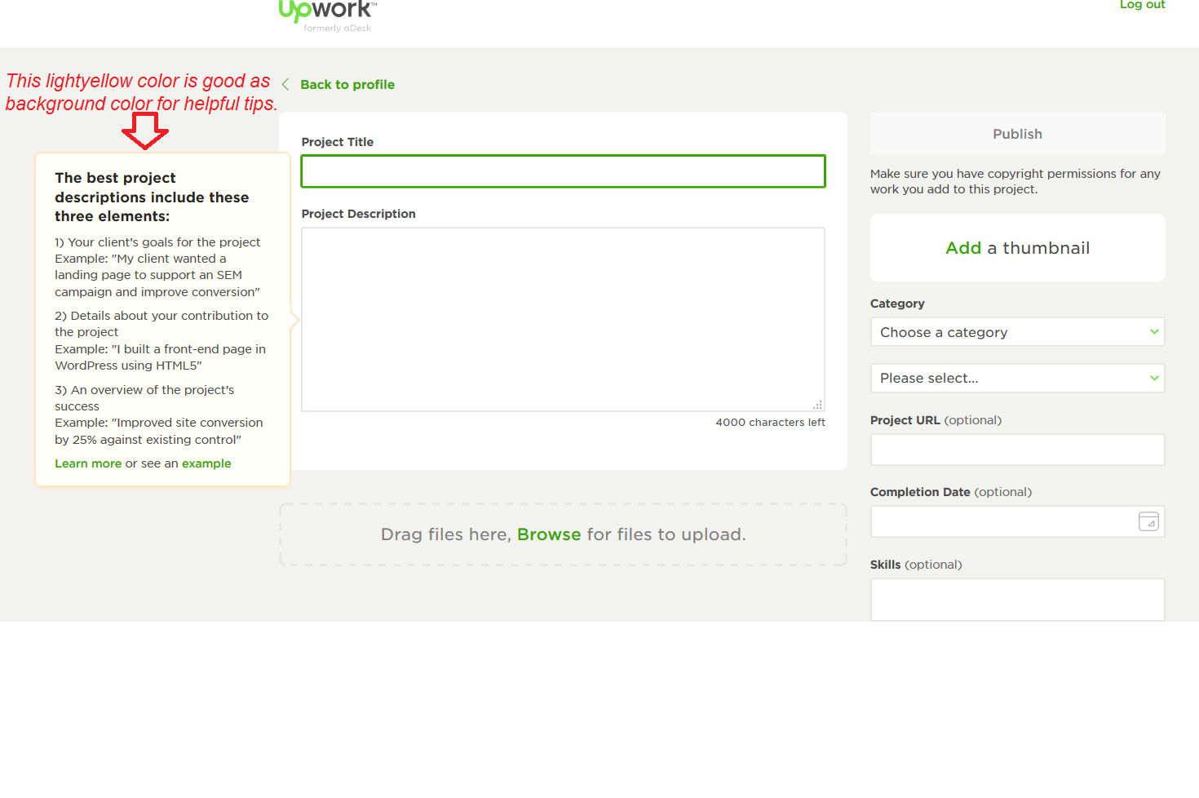
PIPL[23-09-2015] : We have done please have a look.

Lilian [9-26]: The yellow color looks nice. Thank you.
--------------------------------------------
33. In dashboard, here is a word correction:
"My Favourtie people" is spelled wrong. It needs to be "My Favorite People
"My Favourties" is spelled wrong. It needs to be "My Favorites"

PIPL[23-09-2015] : We have already done please have a look.
-------------------------------------------------
34 . Are we making sure Service Profile name is globally unique, and User name is globally unique?
Amol’s answer: yes, they are.
Lilian’s comment: please see the service profile I created under “Hancy”. There are multiple service profile with profile name of “LA.Voice”, so this is clearly not working properly.
PIPL[23-09-2015] : We have already done please have a look.
-------------------------------
New issue:
35. Profile name’s hints is wrong. Please use the following
“Create a profile name without space. You can use “_”, or “.”.
Profile name can be given out for the world to find your published profile. So create one that properly brands you. For example, “WestSide.Painter”; “BestMathTeacher”, etc. You can also use your trade name, business name that’s already established.”

PIPL[23-09-2015] : We have done please have a look.

Lilian [9-26]: This tests OK. However for the detailed hint, if they want to read more, click on a "Read More" link to jump into a section in the FAQ page.

-------------------------------------------
36. City and zipcode needs to work it out. Type “los Angeles”, then no zipcode available. The only way to do it is I have to type “Los Angeles” very very slow, until the pop-up list box shows up. Users in general type much fast, so as long as the city matches, the matching zipcode should appear.
PIPL[23-09-2015] : Its working fine. Please check this on live site.

Lilian [9-26]: Now I can manually type in a city, but still cannot type the zipcode.
For example I typed in “Los Angeles”, without selecting one from drop-down list, the zipcode box does not show any zipcode.

------------------------------------------------------
37. When search for work, the task name gets cut out very short at the search result screen.
For example, “Look for a math tutor” is cut to “Look for a”. that’s only 10 characters. Awfully short.
PIPL[23-09-2015] : We have done please have a look.

Lilian [9-26]: You changed into 15 characters. Can we change into 20 characters.
Also I need to know the maximum length of this field. Potentially set it as maximum (25)

-----------------------------------------------------------
38. Need a default cover photo for both service profile and task. Otherwise it looks really odd.
PIPL[23-09-2015] : We have done please have a look.
-----------------------------------------------------------
39. When showing the interest, it needs to prompt workers to select which service profile he will choose to apply the work with.
PIPL[23-09-2015] : Done but check once.
Lilian [9-26]: It’s the same. Where is the fix?
-----------------------------------------------------------
40. Within a posted task, Total # of bids remains as “0”, even after a worker login and showed the interest.
PIPL[23-09-2015] : It comes in Phase-IV.
---------------------------
9-27 (Sunday)
41. Posted Task needs to have a public view within the dashboard. Ok we will have
42. The picture for the task needs to utilized. Slider of images below the cover image in post task , and label hint for supportive formats (post task function)

PIPL[28-09-2015] : We have Done please have a look.

43. For a worker’s service profile, what’s the difference among Testimonials, Reviews and Recommendation, from your point of view? Here is what I think how they should be:
- For workers, they need recommendations and review:

- Recommendation can come from previous clients, Facebook friends, Linkedin Connection, or RollingPear friends.
- Review allows previous clients to describe their experience with the worker in their own words. Yes it is there

Reviews in the service profile and testimonials in public profile,, and in public profile all the services will be shown.

- For employers, they also will receive reviews. But you have told us secret reviews and it is in phase 4.

- For RollingPear itself, homepage could display testimonials from both employers and workers on RollingPear site. Yes the functionality is present and we have given admin to set which testimonial he wants user to see.
PIPL[28-09-2015] : We have Done please have a look.
44. Why the work examples are not showing up in the public view of Service Profile? , covered and will show
PIPL[28-09-2015] : We have Done please have a look.

